A Conceptual Framework to Address Equity and Efficiency Challenges in Ghana’s Computerized School Selection and Placement System: Insights for Enrollment, Policy, and Practice
Abstract
While Ghana's Free SHS policy has expanded access to secondary education, enrollment challenges persist, with a significant number of placed students (approximately 194,862 between 2019/20 and 2022/23) not enrolling due to system-related, demographic, social, and institutional factors. This study examines the systemic challenges of Ghana's CSSPS and develops a framework to address its equity and efficiency. Data were collected through a questionnaire from 267 students from a population of 865 using the Raosoft sample size calculator and a multi-stage stratified random sampling technique, and analyzed using descriptive statistics and multiple regression. Key factors influencing enrollment success were examined, including feedback clarity, data utilization, decentralized processes, school preference consideration, and Category “A” school denial, which were all significant. These findings highlight the need for reforms in CSSPS policies and practices to enhance enrollment outcomes and maximize the benefits of the Free SHS policy, and recommend the implementation of the proposed framework.
Keywords
Computerized School Selection and Placement System (CSSPS), Enrollment, placement, Ghana Education Service (GES), and Ghana National Association of Private Schools
Introduction
Ghana’s Free Senior High School (SHS) policy was introduced to improve access to secondary education nationwide. While the policy has significantly increased enrolment from 800,000 in 2016 to 1.6 million in 2024 (Ghana News Agency, 2024), data suggests that a considerable number of placed students do not proceed to enroll. For instance, between the 2019/20 and 2022/23 academic years, approximately 194,862 candidates did not take up their SHS placements (3News, 2024). In 2019 alone, 55,056 out of 459,912 qualified students (11.9%) did not enroll (Acheampong, 2021).
Although the 2024 academic year saw the highest-ever first-year enrolment, 504,580 out of 554,033 placed students (91.07%), this still left over 49,000 students unaccounted for (DailyGuide Network, 2024). Additionally, about 104,918 students were not automatically placed and had to rely on the Self-Placement system to secure admission (Yen, 2024). These trends highlight persistent gaps in the Computerized School Selection and Placement System (CSSPS).
An exploratory survey conducted at the Free SHS Secretariat in 2024 revealed that in the Bunkpurugu-Nakpanduri District alone, from 2019 to 2023, 11,085 students were placed, but only 8,188 enrolled, leaving 2,895 (26.13%) who did not. A significant number of those who enrolled did so through self-placement, underscoring concerns with the system’s ability to match students effectively to schools.
Scholarly work has identified a range of contributing factors to these enrolment gaps. These include system-related issues (Kwasi & Opoku, 2021), as well as broader demographic, social, and institutional influences (Cabrera & La Nasa, 2000; Kim, 2004; Shank & Beasley, 1998). Specific critiques of CSSPS highlight equity disparities in access to preferred schools, especially for students from disadvantaged backgrounds (Asare & Osei, 2018), and challenges stemming from the 30% priority placement allocation for public JHS students into Category A schools (GNAPS, 2022). Additionally, the centralized structure of the system has been criticized for inefficient feedback mechanisms (Mensah, 2020) and its overreliance on academic scores, to the neglect of student interests, skills, and extracurricular achievements (Owusu & Nettey, 2022).
Despite its potential to promote fair and efficient school placements, the CSSPS continues to face significant challenges. To address these, this study proposes the development of a conceptual framework that offers insights for improving equity and efficiency within the placement process.
Addressing these systemic issues is critical for Ghana’s educational reform and broader national development. Equity ensures that all students, regardless of background, have fair access to quality education, while efficiency ensures optimal use of resources and minimizes administrative challenges and enrollment losses. Together, they contribute to a stronger, more inclusive educational system capable of preparing a skilled workforce for the future.

Literature Review
Overview and Operational Dynamics of the CSSPS in Ghana
The implementation of Ghana’s Computerized School Selection and Placement System (CSSPS) in 2005 marked a significant transformation in the country's educational landscape, particularly in managing the transition of students from junior high school (JHS) to senior high school (SHS). Before its introduction, student placement was conducted manually, a process marred by inefficiencies, favoritism, and a lack of transparency (Owusu-Ansah, 2015). These traditional approaches not only delayed placements but disproportionately disadvantaged students in less privileged regions, further entrenching educational inequities (Adjei & Agyemang, 2018).
To address these concerns, the Ghanaian government introduced the CSSPS as a digital placement mechanism designed to enhance fairness and reduce logistical complications associated with manual processes (Mensah, 2020). According to Gyaase and Gyamfi (2012), the CSSPS also aligns with broader e-governance principles by promoting transparency, reducing human biases, and automating public service delivery in the education sector (Patnaik, Pattnaik & Singh, 2020).
Administered by the Ghana Education Service (GES), the CSSPS is responsible for placing students who have completed the Basic Education Certificate Examination (BECE) into SHS or Technical and Vocational Education and Training (TVET) institutions. BECE candidates select five schools in order of preference, indicate their desired programs of study and residential status (Day or Boarding), and must also choose a compulsory Day option from Category D schools within their locality (Ghana Education Service, 2023). These selections are facilitated through a school register and supervised by school authorities and parents. Once completed, the data is uploaded by District Examination Officers to the West African Examinations Council (WAEC) system.
Candidates can verify their school selections through an SMS platform. Upon release of BECE results, an automated algorithm uses candidates’ performance in core and elective subjects to determine placements, prioritizing merit and declared preferences. In cases of oversubscription, a tie-breaking mechanism is employed based on aggregate scores. Students access their placement outcomes via SMS or an online portal. Those who do not receive automatic placement are directed to a self-placement system to choose from schools with available space. Manual placements are reserved for special categories such as gifted students or seminarians (Ghana Education Service, 2023).
While the CSSPS has significantly improved placement transparency and efficiency compared to the former manual system (Ajayi, 2009), challenges persist, particularly regarding equity and operational efficiency. Studies continue to highlight gaps in the system's ability to ensure fair access to preferred schools, especially among students from disadvantaged backgrounds (Asare & Osei, 2018). These limitations underscore the need for further refinement of the CSSPS to enhance its responsiveness to students' diverse needs and circumstances.
Equity Challenges in Ghana’s CSSPS
One major equity concern in Ghana’s CSSPS is the limited alignment between student preferences and actual school placements. Research estimates that approximately 46% of Junior High School (JHS) students each year are not placed in their preferred Senior High Schools (SHSs) (The Conversation, 2022). This mismatch can lead to decreased motivation, student dissatisfaction, and even attrition, particularly among students from low-income backgrounds who lack the resources to pursue alternative options such as transfers (Babah et al., 2020; Gyamfi, 2023; Osei, 2021; Tamanja & Pajibo, 2019; Mensah, 2020).
Preference-based placement systems have been shown to improve student engagement, satisfaction, and academic performance (Schneider & Buckley, 2002; Hoxworth, 2020). However, oversubscription of top-tier schools creates a structural limitation. For example, Isare (2010) reported that while Wesley Girls’ High School had only 300 available spaces, over 12,000 students selected it as their first choice. Such disparities reveal the CSSPS's difficulty in meeting demand while preserving equity.
In addition to preference mismatches, the 30% priority placement policy further complicates equitable access. This policy reserves 30% of places in Category “A” SHSs for students from public JHSs, with the remaining 70% open to all applicants. While intended to promote inclusion, critics argue it disadvantages private school students, many of whom come from underserved communities. According to Damasus Tuurosong of the Ghana National Association of Private Schools (GNAPS), the policy undermines meritocracy and unfairly penalizes students from private institutions seeking quality education (GNAPS, 2024a–c). GNAPS has formally petitioned the Commission on Human Rights and Administrative Justice (CHRAJ) to review the policy’s constitutionality. Scholars have echoed these concerns. Babah et al. (2020) argue that the system’s prioritization policies disproportionately benefit public school students and call for more equitable placement criteria. Similarly, Mensah (2020) found widespread stakeholder dissatisfaction with the current allocation model, particularly among private school representatives. Former CSSPS Coordinator Atta-Boateng (2019) also emphasized that many placement issues stem from avoidable policy decisions and recommended a comprehensive system review.
Together, these studies point to structural inequities in the CSSPS that disproportionately affect certain student populations. Addressing these concerns is vital for ensuring that school placement policies uphold both fairness and access in Ghana’s education system.
Efficiency Challenges in Ghana’s CSSPS
Since its inception, the CSSPS in Ghana has faced several efficiency-related challenges that hinder its ability to meet the diverse needs of students and stakeholders. One prominent issue is the system's limited use of student data in placement decisions. The CSSPS primarily relies on Basic Education Certificate Examination (BECE) scores, neglecting other important indicators such as student interests, aptitudes, and extracurricular achievements. This narrow focus on academic performance can obscure a holistic understanding of students’ potential, leading to misalignments between student profiles and school environments (Rosenbaum, 2001).
Several studies underscore the value of incorporating diverse data points in school placement decisions. Cohen and Hill (2000) and Schwartz et al. (2013) highlight that considering non-academic factors such as interests and co-curricular involvement can enhance personalization, improve student satisfaction, and foster long-term engagement. Parents and students often express frustration that the CSSPS fails to account for these dimensions, resulting in placements that overlook students’ broader capabilities (Owusu et al., 2022; Mensah & Tutu, 2021).
Babah et al. (2020) argue that this overemphasis on academic scores risks ignoring students’ diverse talents, potentially leading to disengagement and lower performance. Similarly, Gyamfi (2023) emphasizes that extracurricular involvement contributes positively to students’ cognitive and socioemotional development, but the CSSPS currently lacks mechanisms to recognize or integrate such factors. Osei (2021) also stresses the need for a more comprehensive placement system that accounts for student strengths beyond academic achievement, particularly to support learners from marginalized backgrounds who may face structural barriers to excelling in standardized exams.
Another major efficiency challenge lies in the centralized nature of the CSSPS and its inadequate feedback and complaint handling mechanisms. Centralized systems often struggle to accommodate the diverse and localized needs of their users. According to Kossyvaki et al. (2018) and McGuinn (2006), such systems can create a disconnect between administrative processes and the real-world experiences of students and parents, often leading to unresolved concerns and stakeholder dissatisfaction.
Timely and responsive feedback is essential in educational placement systems. Hattie and Timperley (2007) assert that feedback loops are crucial for continuous improvement. However, in the CSSPS, feedback channels are often underdeveloped or slow to respond. This inefficiency hampers the resolution of placement grievances and fosters mistrust among users (Baker, 2015; Grubb, 2009). The CHS Alliance (2019) further supports this concern, noting that centralized systems frequently struggle with effective complaint resolution, thereby underscoring the need for decentralized or hybrid models to ensure responsiveness and improve user satisfaction.
These efficiency challenges highlight critical gaps in the CSSPS’s design and implementation. Addressing them requires structural reforms that incorporate broader student data, decentralize feedback systems, and improve stakeholder engagement to ensure a more adaptive and equitable placement process.
International Models of Student Placement Systems: Lessons for CSSPS Reform
Student placement systems around the world offer valuable insights into how equity and efficiency challenges can be addressed through algorithmic fairness, holistic admissions, and decentralized governance. This section highlights international models and strategies that may inform reforms to Ghana’s Computerized School Selection and Placement System (CSSPS).

1. Matching Algorithms and Student Preferences
A foundational contribution to fair placement systems is the Deferred Acceptance Algorithm (DAA), introduced by Gale and Shapley (1962) in their seminal paper, College Admissions and the Stability of Marriage. The DAA allows students to submit ranked preferences for schools, while schools consider these applications based on capacity and applicant qualifications. Through an iterative process of acceptance and rejection, the algorithm matches students with schools in a way that minimizes preference mismatches and improves overall stability.

This algorithm has been successfully applied in school placement systems in countries such as the United States, the United Kingdom, and Australia (Abdulkadiroğlu, Pathak, & Roth, 2005; Abdulkadiroğlu & Sönmez, 2003). These implementations have demonstrated improvements in placement satisfaction, reduced oversubscription conflicts, and increased transparency. Adapting the DAA for CSSPS could help resolve current mismatches between student preferences and placements, especially in oversubscribed schools, as illustrated by Isare (2010).

2. Holistic Admissions and Non-Academic Criteria
Several countries have adopted placement models that incorporate multiple student characteristics beyond academic scores. In the United States, many universities employ holistic admissions criteria considering grades, extracurricular activities, personal essays, and teacher recommendations (Cohen & Hill, 2000). The University of California, for example, has reduced reliance on standardized testing in favor of comprehensive student profiles (University of California, 2020).
Finland’s vocational education and training (VET) system integrates academic learning with career guidance, aligning students’ interests and skills with their educational paths (Sahlberg, 2011). Similarly, Germany’s dual education model blends apprenticeships and classroom learning to match students to vocational tracks based on practical ability (Euler, 2013).
In Singapore, student placement considers co-curricular activities and personal development alongside academic records. The Ministry of Education aligns placements with both achievements and aspirations (Ng, 2014). Likewise, New Zealand’s National Certificate of Educational Achievement (NCEA) permits students to earn credits across academic, vocational, and extracurricular domains (Ministry of Education, New Zealand, 2018). These models support more personalized and inclusive placement strategies that the CSSPS could adopt to recognize diverse student capabilities.

3. Decentralization, Feedback, and Flexibility
Decentralized systems allow for more responsive placement procedures and better stakeholder engagement. In the Netherlands, school choice is managed at the municipal level. Parents and schools collaborate on placements, taking into account academic performance, personal circumstances, and social equity factors (Kons, 2016). A robust feedback system, including online platforms and municipal support offices, facilitates transparent and timely grievance resolution.
The United Kingdom’s Post-16 Pathways System offers students flexible educational choices, academic (A-Levels) or vocational (BTEC, apprenticeships), alongside structured career counseling and advisory services (Department for Education [DfE], 2018). Its complaint handling system includes multi-tiered redress options that enhance responsiveness and institutional trust (McGuinn, 2006).

Applying elements of these systems, such as decentralized complaint resolution, career guidance, and diversified placement tracks, can strengthen the CSSPS’s capacity to serve varied learner needs while improving public confidence in the process.
Together, these international models demonstrate that integrating student preferences, non-academic factors, and localized decision-making can promote fairness, improve satisfaction, and increase placement efficiency. Ghana’s CSSPS can benefit from these global practices to create a more equitable and responsive placement system.
Theoretical Frameworks
A robust theoretical foundation for analyzing the equity and efficiency challenges of Ghana’s Computerized School Selection and Placement System (CSSPS) can be drawn from four key frameworks: social justice theory, fairness in education, systems optimization theory, and e-governance theory.
Equity-Oriented Theories:
Social justice theory, as articulated by Rawls (1971), emphasizes the equitable distribution of opportunities and resources. In the context of CSSPS, this implies ensuring that all students, regardless of socioeconomic background, have fair access to preferred and quality senior high schools. Fraser’s (1997) theory of fairness in education reinforces this idea by advocating for procedural justice, where transparency, inclusion, and recognition of diverse needs are central to educational policy.
These frameworks directly relate to current CSSPS issues, such as the limited consideration of student preferences and the controversial 30% priority placement for public JHS students, which some stakeholders argue undermines meritocracy and equity.
Efficiency-Oriented Theories:
From an operational perspective, systems optimization theory (Bertalanffy, 1968) suggests that educational systems like the CSSPS should be designed to maximize outcomes while minimizing inefficiencies. Challenges such as inadequate data use, over-reliance on BECE scores, and slow feedback or complaint resolution mechanisms indicate a need for system reengineering to align with optimization principles.
E-governance theory (Heeks, 2006) provides a complementary digital lens, advocating for the use of information and communication technologies to improve public service delivery. In the CSSPS context, this translates to the integration of real-time feedback systems, data-driven placement tools, and transparent complaint handling mechanisms to enhance user trust and system efficiency.
Together, these theories offer a multidimensional lens to assess and improve CSSPS functionality, balancing the imperative for fairness with the need for operational effectiveness.

Conceptual Framework to Address Equity and Efficiency Challenges in Ghana’s CSSPS
The conceptual framework presented in Figure 1 is directly informed by the theoretical foundations outlined above. Social justice theory and Fraser’s fairness in education provide the normative basis for identifying and addressing equity-related challenges in the CSSPS, such as the limited incorporation of student preferences and the perceived exclusion of private JHS students from high-demand Category “A” schools. Systems optimization theory and e-governance theory underpin the efficiency dimension, highlighting the operational weaknesses of a centralized placement model and the system's inadequate feedback and data utilization mechanisms. Together, these theories not only frame the diagnosis of CSSPS challenges but also inform the structure and focus of the conceptual framework. This theoretical-conceptual linkage ensures that the study’s analysis and recommendations are grounded in both established scholarly principles and practical system-level realities.
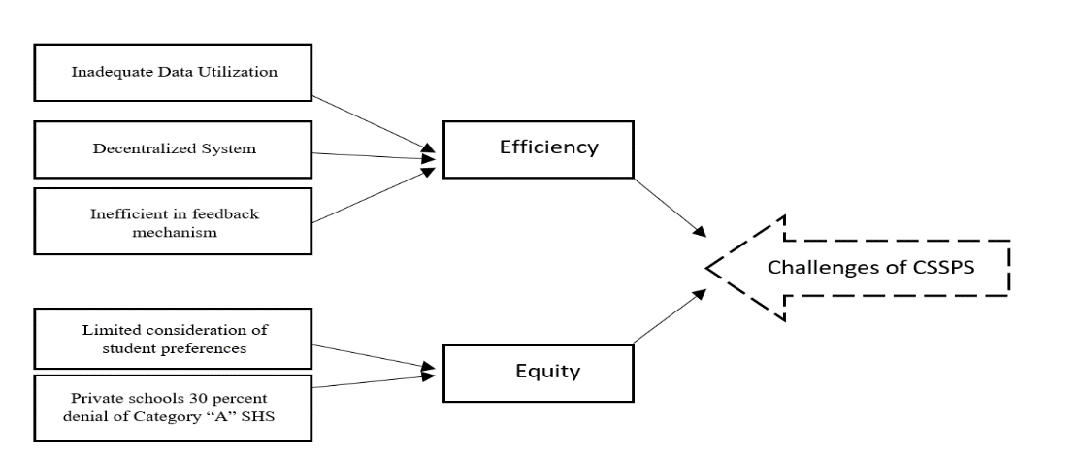
Figure 1. Challenges of CSSPS
Source: Author's Construction
These theoretical insights inform not only the diagnosis of CSSPS challenges but also shape the proposed interventions, which are operationalized through the following hypotheses:
- H1: Removing or revising the 30% priority placement policy for public JHS students in Category A schools will significantly increase enrolment success. (Linked to equity, fairness, and social justice)
- H2: A multi-criteria placement system that incorporates students’ interests and co-curricular activities will significantly enhance enrolment. (Grounded in fairness and systems optimization)
- H3: Implementing a real-time feedback mechanism in CSSPS will significantly increase enrolment success. (Rooted in e-governance and responsiveness)
- H4: A placement system that considers students' preferences by using iterative algorithms that tentatively place or reject students and allow them to make other selections until they are placed will significantly increase enrolment success. (Linked to fairness and efficiency through algorithmic optimization)
- H5: A decentralized yet coordinated school placement model will significantly increase enrolment success. (Anchored in systems optimization and e-governance frameworks)
Together, these hypotheses represent testable propositions derived from the intersection of theory and practice. This integration ensures that the study’s analysis and recommendations are not only empirically grounded but also theoretically robust, providing a structured pathway for assessing how targeted reforms could enhance both the equity and efficiency of the CSSPS.

Methodology
This study employed a quantitative research design using standard multiple regression analysis to examine the relationship between enrollment success and five key challenges in the Computerized School Selection and Placement System (CSSPS). This design was appropriate for assessing the relative impact of multiple predictors while controlling for inter-variable influence (Field, 2018). Multiple regression is commonly applied in educational research to model complex relationships (Pallant, 2021) and detect issues like multicollinearity using variance inflation factors (VIF) and tolerance values (Tabachnick & Fidell, 2012).
Population and Sampling
The study focused on Senior High School (SHS) students from four schools across four regions in Ghana, selected for their regional diversity and differing placement patterns within CSSPS. The total target population was 1,871 students, from which an accessible population of 865 SHS 2 students was identified. A sample of 267 respondents (31% of the accessible population) was determined using the Raosoft sample size calculator at a 5% margin of error and 95% confidence level.
A multi-stage stratified random sampling technique was employed. Students were first stratified by school, then selected through simple random sampling using the lottery method within each stratum (Seidu, 2007).
Data Collection Instrument
Data was gathered using a researcher-administered questionnaire, which was piloted and validated before implementation. The instrument assessed perceptions of five major challenges associated with CSSPS:
- Inefficient Feedback Mechanism
- Inadequate Data Utilization
- Centralized System
- Limited Consideration of Student Preferences
- Denial of Access to Category “A” SHSs for Private JHS Students
Data Analysis
Descriptive statistics were used to summarize the data, while standard multiple regression (via SPSS) examined the relationship between the five CSSPS challenges and student enrollment success. The model's overall significance was tested using the F-statistic.
Assumptions for multiple regression (N = 267) were tested and satisfied. Outliers were addressed using Mahalanobis Distance and Cook’s Distance, with extreme values treated through Winsorization. No multicollinearity was detected (VIF and Tolerance values were within acceptable ranges). Residual plots and histograms confirmed linearity, normality, and homoscedasticity.
Descriptive results indicated a high mean for enrollment success (M = 4.34, SD = 0.720) and the highest variability in data utilization scores (SD = 1.128), supporting the model’s reliability.
Ethical Considerations
The study adhered to established ethical guidelines. Approval for data collection was obtained via an official introductory letter and authorization from the school authorities. Participants were fully informed of the study's purpose, and informed consent was obtained voluntarily (Bryman, 2012). Respondent confidentiality was ensured by removing identifiable information and using coded identifiers during data transcription and analysis.
Results
A Standard multiple regression was employed in this study to examine the relationship between Feedback Clarity, Data Utilization, Decentralized Process, School Preference Consideration, and 30% Category “A” School Denial (independent variables) and enrollment success (dependent variable). This method was selected as it allows for the simultaneous analysis of multiple predictors and outcome variables, providing insights into the relative contributions of each independent variable to the variance in enrollment success. The study hypothesized four non-directional hypotheses regarding the impact of Feedback Clarity, Data Utilization, Decentralized Process, School Preference Consideration, and 30% Category A School Denial on enrollment success.
Before conducting a multiple regression analysis, preliminary assumptions were performed to check for sample size, outliers, normality, linearity, and homoscedasticity. The results revealed that not all the assumptions were not violated.
Sample Size
Sample size is crucial for ensuring the generalizability of research findings. According to Pallant (2021), a sample size of at least 30 participants is typically recommended for most statistical analyses. However, for multiple regression, Field (2018) suggested a minimum of 10 to 15 cases per independent variable. In this study, with a sample size of 267 and 5 independent variables, there were approximately 53.4 cases per factor, exceeding the recommended guidelines.
Furthermore, Garson (2012) proposed a rule of thumb for calculating the minimum sample size for multiple regression as N ≥ 50 + 8m (where m is the number of predictors). In this study, with m = 5, the required sample size was 90 (i.e., 50 + 8 * 5). As the actual sample size (N = 267) surpassed this threshold, the sample size was adequate for the multiple regression analysis.
Multicollinearity Test
To test for multicollinearity, the Variance Inflation Factor (VIF) and Tolerance values were examined (Daoud, 2017). Tolerance represents the proportion of variance in a predictor that is not explained by the other predictors (TOL = 1 - R²), while VIF is its reciprocal (VIF = 1 / Tolerance). High VIF values indicate potential multicollinearity issues. According to Daoud (2017), a VIF value greater than 10 suggests problematic multicollinearity, while a tolerance value below 0.1 indicates redundancy. As shown in Table 1, all VIF values were below 10 and all Tolerance values were above 0.1, indicating that multicollinearity was not a concern in this regression model.
Table 1: Students’ Tolerance and VIF values for the predictor variable
Variable | Tolerance | VIF
Feedback Clarity (Q1) | 0.969 | 1.032
Data Utilization | 0.966 | 1.035
Decentralized Process | 0.994 | 1.006
School Preference Consideration | 0.960 | 1.042
Category A School Denial | 0.958 | 1.044

Source filed work, 2024
Test for linearity, Normality, and Homoscedasticity
To evaluate the assumptions of linearity, normality, and homoscedasticity, residual plots are examined. Residuals, which are the differences between observed and predicted values, should be randomly distributed around zero when these assumptions hold.
Normality was assessed using a histogram, a scatter plot (Figure 2), and a Normal P-P Plot of Regression Standardized Residuals. A histogram approximating a bell-shaped normal curve, coupled with a nearly straight line on the normal probability plot, is indicative of normality. The histogram (Figure 3) closely resembled a normal distribution (mean = 8.23E-16, standard deviation = 0.980), and the normal probability plot exhibited approximate linearity. Furthermore, the Normal P-P Plot (Figure 4) of Regression Standardized Residuals (Enrollment Success) showed data points clustering near the diagonal line, confirming that the residuals were normally distributed. These findings support the assumption of normality. Figure 2: Students’ Scatter plot of Regression Standardized Residuals against Regression Standardized Predicted value.
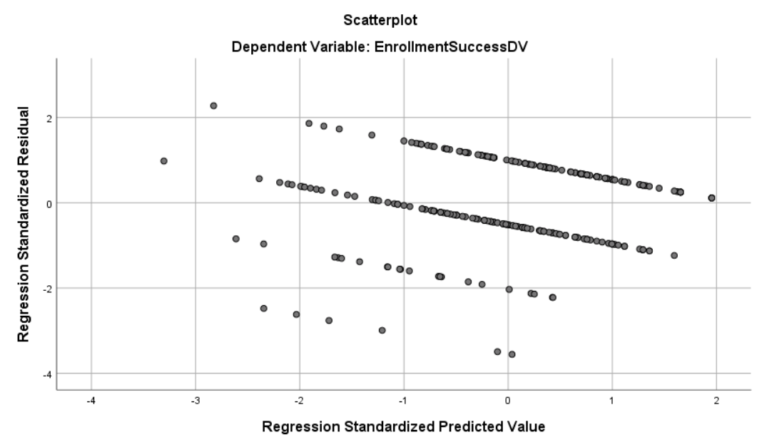
Figure 2: Students’ Histogram of Regression Standardized Residuals
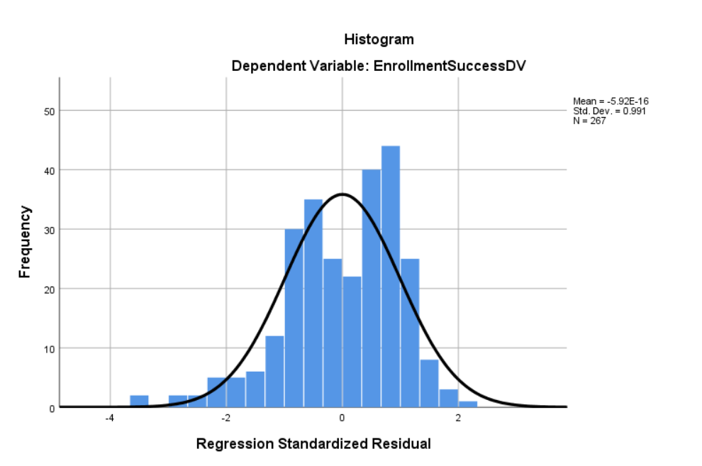
Figure 3: Students’ Normal Probability Plot
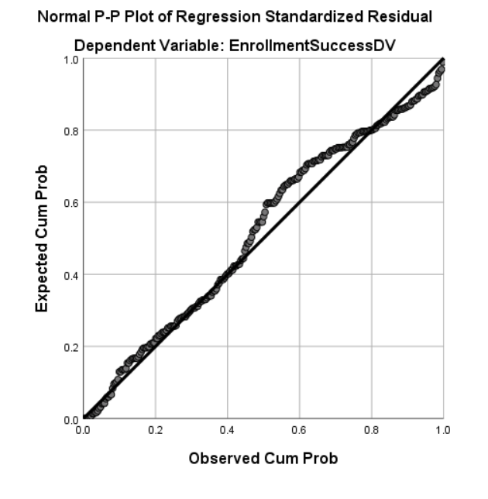
Figure 4: Students’ Normal P-P Plot

Results of Students’ Multiple Regression Analysis
Table 2 presents descriptive statistics for the variables included in the multiple regression analysis, providing a snapshot of the data. The mean and standard deviation for each variable, including final score, age, gender, prior knowledge, personal characteristics, and preference, were displayed. These statistics offer initial insights into the data's central tendency and variability.

Table 2: Descriptive Statistics of Students’ Test Scores
Variables | Mean | Std. Deviation | N
Enrolment Success | 4.34 | .720 | 267
Feedback Clarity | 4.38 | .628 | 267
Data Utilization | 3.95 | 1.128 | 267
Decentralized Process | 3.73 | 1.187 | 267
School Preference Consideration | 4.35 | .727 | 267
Category “A” School Denial | 4.17 | .934 | 267
Source filed work, 2024

The descriptive statistics table shows, for example, that "Enrollment Success" has a mean of 4.34, suggesting a relatively high average rating on enrollment success, while its standard deviation of 0.772 indicates that responses are fairly close to this average. In contrast, "Data Utilization" has a mean of 4.14 but a larger standard deviation of 1.128, indicating that responses on data utilization are more spread out, with some participants likely having more varied opinions or experiences. All variables have an N of 267, meaning the analysis includes 267 observations for each. These statistics imply that while enrollment success is generally rated favorably with relatively consistent responses, data utilization shows more variability in responses, which could suggest differing levels of effectiveness or understanding in this area.

Results
A standard multiple regression analysis was conducted to examine the relationship between the dependent variable, enrolment success, and five independent variables: feedback clarity, data utilization, decentralized process, school preference, and consideration category "A" school denial. SPSS Regression and Explore were used to analyze the data. Assumptions of outliers, normality, linearity, and homoscedasticity of residuals were assessed and found to be acceptable. The regression model was statistically significant, F (5, 261) = 10.88, p < .001, suggesting that the independent variables as a group were significantly related to students' final score, with R² = .172, as displayed in Table 3. This indicates that 17.2% of the variance in enrolment success can be explained by the predictor variables. The adjusted R² of .157 suggests that 15.7% of the variance remains after accounting for the number of predictors. Correlations between variables, unstandardized regression coefficients (B), standardized coefficients (β), partial correlation, part correlation, and part-squared are presented in Table 4

In the bid to examine the relative importance of the independent variables, the standardized β values were used. Table 4 shows the results of the multiple regression, indicating that all five predictor variables significantly influenced enrolment success at the alpha level of .05. Regarding the individual predictors, feedback clarity (β = .285, t(261) = 4.38, p < .001), data utilization (β = .108, t(261) = 2.97, p = .003), decentralized process (β = .090, t(261) = 2.62, p = .009), school preference (β = .151, t(261) = 2.70, p = .007), and consideration category "A" school denial (β = .099, t(261) = 2.29, p = .023) emerged as significant positive predictors of enrolment success. This implies that higher levels of each of these variables were associated with higher final scores.

The analysis revealed that feedback clarity made the most significant unique contribution to the enrolment success. This was followed by school preference, data utilization, consideration category "A" school denial, and decentralized process.

The part correlation values in Table 4 also confirmed the unique contribution of each independent variable. These values, when squared, indicate the amount by which R² would be reduced if a predictor variable were dropped from the model. The part-squared values revealed that feedback clarity was the most important predictor of enrolment success, explaining 25% of the variance. This was followed by data utilization (16%), school preference (4.84%), consideration category "A" school denial (4%), and decentralized process (3.24%). Thus, considering both beta and part-squared values for all the predictor variables, it is evident that feedback clarity, data utilization, school preference, consideration category "A" school denial, and decentralized process were significant predictors that contributed to the enrolment success.

Table 3: Students’ Analysis of Variance
Sources | Sum of Squares | Df | Mean Square | F | R | R² | Adjusted R² | P
Model | 23.802 | 5 | 4.760 | 10.881 | .415ª | .172 | .157 | .000^{b}
Error | 114.183 | 261 | .437
Total | 137.985 | 266
P<.05
Source filed work, 2024

Table 4: Students’ Multiple Regression on dependent variable (Final score)
Variable | B | Β | T | P | Partial correlation | Part correlation | Part squared
feedback clarity | .248 | .285 | 4.380 | .000 | .262 | .247 | .25
data utilization | .169 | .108 | 2.972 | .003 | .181 | .167 | .16
decentralized process | .147 | .090 | 2.617 | .009 | .160 | .247 | .0484
School preference consideration | .153 | .151 | 2.695 | .007 | .165 | .152 | .0324
category “a” school denial | .129 | .099 | 2.285 | .023 | .140 | .129 | .04
P<.05
Source filed work, 2024

Discussion

The multiple regression analysis revealed that feedback clarity, data utilization, decentralized process, school preference, and consideration category "A" school denial significantly influenced enrolment success. These findings have important implications for the equity and efficiency hypotheses proposed for the CSSPS.
This study explored students’ perceptions of enrollment success and their experiences with the Computerized School Selection and Placement System (CSSPS) in Ghana. The findings provide insight into how the inefficiency of feedback mechanisms, inadequate data utilization (especially regarding student interests and co-curricular activities), the centralized structure of the CSSPS, limited consideration of student preferences, and the 30% Category A placement policy collectively impact enrollment outcomes.
Feedback clarity was the most significant predictor of enrollment success (β = .285, p = .000), supporting H3, which posited that implementing a real-time feedback mechanism in CSSPS would significantly increase enrollment success. Students reported that delays or a lack of clarity in feedback caused confusion and anxiety, reinforcing the importance of timely, transparent communication (Teye & Quarshie, 2020). Prior studies affirm that structured, prompt, and constructive feedback is essential in educational decision-making. For example, a study at Majmaah University found that 67.8% of students were dissatisfied due to insufficient feedback, negatively affecting their learning experiences (Alsaleem et al., 2018). Moreover, research by Ajjawi et al. (2024) emphasized how fragmented feedback forces students to self-interpret their academic standing, increasing uncertainty. Agyekum and Yeboah (2024) also highlighted that diverse and timely feedback strategies significantly improve student learning outcomes, particularly in high-stakes contexts such as placement and assessment.
Data utilization, referring to how student co-curricular activities and interests are incorporated into placement, also had a significant impact (β = .108, p = .003), supporting H2. This suggests that a more holistic, multi-criteria approach to placement beyond academics alone can enhance students’ engagement and satisfaction with the process. Research by Mensah and Frempong (2022) similarly highlights the value of including student interests in educational decision-making.
Prior research supports this, showing that incorporating students' interests and non-academic strengths can improve educational engagement and outcomes. For example, Wang and Degol (2016) emphasized the importance of interest congruence in educational pathways, highlighting how alignment between student interests and learning environments fosters motivation and success. Similarly, Niu (2017) found that students' participation in co-curricular activities contributes significantly to their cognitive and social development, which can positively influence their satisfaction with placement decisions. These studies affirm that factoring in student interests and broader developmental experiences enhances the effectiveness of school placement systems.
The significance of the decentralized process (β = .090, p = .009) affirms H5, which hypothesized that a decentralized yet coordinated school placement model would improve enrollment outcomes. This finding aligns with prior research indicating that decentralization in educational management can lead to enhanced student enrollment and achievement. For instance, a study by Elacqua et al. (2021) in Colombia found that municipalities granted autonomy in education administration experienced improvements in school enrollment and student performance, partly due to better resource allocation and higher-quality teacher recruitment. Similarly, research by Kyeremeh and Kor (2022) in Ghana demonstrated that decentralized educational management positively influenced teacher motivation and discipline, contributing to improved educational outcomes. These studies suggest that decentralization, when effectively implemented, can enhance the responsiveness and efficiency of educational systems, leading to better enrollment outcomes (Carr-Hill, 2013; Faguet & Sánchez, 2008; Upadhyay & Rajasekhar, 2023). While CSSPS is highly centralized, the results indicate that introducing more localized decision-making, while maintaining national standards, could increase responsiveness to students' unique contexts (Bawa & Sule, 2021).
School preference consideration also had a significant effect (β = .151, p = .007), lending support to H4, which emphasized the use of iterative algorithms that account for student preferences. The current one-time placement approach limits flexibility and can lead to dissatisfaction when students are denied their top choices. Iterative placement systems, which allow multiple rounds or adjustments, have been effective in other school matching systems globally (Gale & Shapley, 1962; Abdulkadiroğlu et al., 2005).
Finally, the significance of the 30% Category A placement policy for public JHS students (β = .099, p = .023) supports H1. While the policy aims to promote equity, the findings suggest it may be viewed by some as disadvantaging private school students, thereby reducing perceptions of fairness. Agyemang (2022) and Boateng and Abrokwa (2023) emphasize that policies intended to promote equity must be transparent and inclusive to maintain trust and effectiveness.
In summary, all five hypotheses (H1–H5) were supported by the data, underscoring that enhancements in feedback mechanisms, preference consideration, data integration, decentralized processes, and policy adjustments could significantly improve the CSSPS and enrollment success. Future research should explore these dimensions further through longitudinal and mixed-method studies to assess both immediate and lasting impacts of proposed reforms.
Conclusion
This study examined students’ perceptions of enrollment success and their experiences with the Computerized School Selection and Placement System (CSSPS) in Ghana. Key findings highlight significant concerns related to the inefficiency of feedback mechanisms, limited data utilization (especially regarding student interests and co-curricular engagement), the centralized nature of the placement process, inadequate consideration of student preferences, and the perceived unfairness of the 30% Category A school priority policy.
These findings are significant because they suggest that the current structure of the CSSPS may not fully align with students’ needs and expectations, potentially affecting their satisfaction and success in the school placement process. The study underscores the importance of a more transparent, decentralized, and student-centered placement model that integrates real-time feedback, considers students’ holistic profiles, and allows flexibility in preference matching.
Given the implications of these insights, it is recommended that policymakers consider a reform of the CSSPS framework by piloting iterative, data-informed, and feedback-driven placement approaches. Future research could explore these proposed changes in real-world implementations to evaluate their impact on equity, efficiency, and enrollment outcomes across diverse student populations.
Recommendations
The findings of this study reveal persistent challenges within the CSSPS, particularly concerning fairness, efficiency, and student satisfaction. Key factors such as feedback clarity, data utilization, decentralized processes, school preference, and Category ‘A’ school denial significantly influence enrolment success. These issues highlight the limitations of the current placement system, which, if unaddressed, may continue to hinder equitable access to Senior High School education.
To mitigate these challenges, this study recommends the operationalization of a newly proposed framework aimed at improving the placement process by enhancing transparency, responsiveness, and inclusivity. This framework builds on key insights from the findings, advocating for policy adjustments such as revising the 30% priority placement rule, implementing a multi-criteria placement system that considers students’ interests and co-curricular activities, integrating real-time feedback mechanisms, and adopting an iterative algorithm that allows students to refine their choices. Additionally, a decentralized yet coordinated model is proposed to improve accessibility and efficiency in placement decision-making. By addressing these challenges, the proposed framework serves as a strategic model for optimizing the CSSPS to ensure fairer, more effective school placements. The following section presents the framework in detail, outlining its components and how it can be applied in practice to enhance enrolment success.
Proposed Framework for CSSPS
This new framework (see figure 5) enhances CSSPS by introducing a multi-factor placement model that integrates student interests, skills, and extracurricular achievements alongside academic scores. Additionally, it adopts a Deferred Acceptance Algorithm (DAA) for optimized placement and incorporates a decentralized system with a feedback mechanism to handle grievances efficiently.

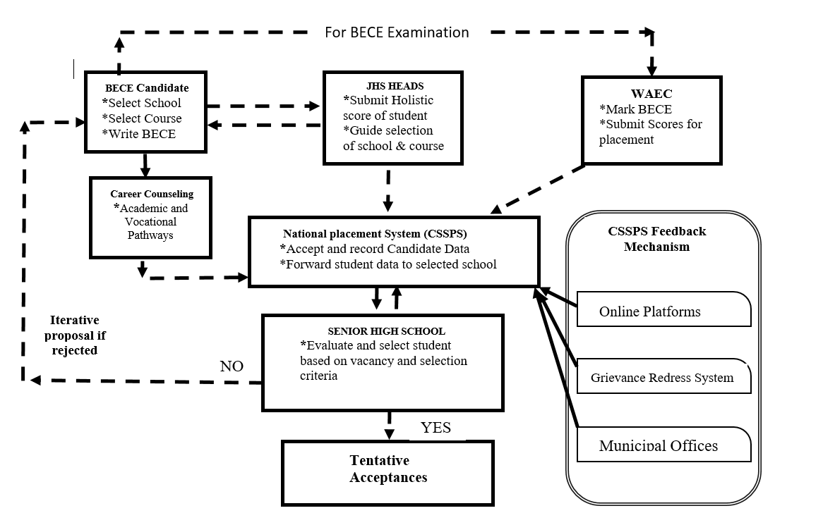

Figure 5. Proposed framework to curtail efficacy and equity challenges of CSSPS
Source: Author's Construction

Enhanced CSSPS Framework for Equitable and Efficient School Placement
The findings of this study reveal significant challenges in the current Computerized School Selection and Placement System (CSSPS), particularly in terms of fairness, efficiency, and student satisfaction. Issues such as lack of transparency, limited consideration of student interests, and inadequate feedback mechanisms contribute to placement inefficiencies. The proposed Enhanced CSSPS Framework aims to address these challenges by incorporating a holistic assessment approach, iterative placement mechanisms, decentralized decision-making, and a robust feedback system. This framework ensures that student placements are more transparent, responsive, and aligned with individual aspirations, ultimately improving enrolment success rates.
Key Components of the Framework
The framework consists of five major components that work together to improve efficiency, fairness, and student satisfaction in school placements.

BECE Candidate
The BECE Candidate stage is the initial step in the Computerized School Selection and Placement System (CSSPS), where JHS students, with guidance from parents, teachers, and career counselors, make crucial decisions about their future education. Before taking the Basic Education Certificate Examination (BECE), students, per the new framework, will log on to the CSSPS to select their preferred Senior High Schools (SHS) and courses based on parental support, career aspirations, and advice from school counselors and teachers. Career counseling plays a vital role in this process by helping students identify their strengths, explore academic and vocational pathways, and align their choices with future career prospects. Once the selection is finalized, students sit for the BECE, which determines their academic score, conducted by WAEC.
Why is this necessary?
- The current system relies solely on academic performance, often leading to placements that do not match students’ strengths or interests.
- Early career counseling and holistic school selection reduce post-placement dissatisfaction and dropout rates.

WAEC
WAEC is responsible for organizing the Basic Education Certificate Examination (BECE), which serves as the basis for student placement into Senior High Schools (SHSs), Technical Institutes, and Vocational Schools. After administering the BECE, WAEC marks and compiles the results, and sends them to the CSSPS unit under the GES to facilitate the school selection and placement process.
Junior High School (JHS) Heads
Unlike the CSSPS, where placement decisions are based on merely academic scores, the JHS Heads play a crucial role in this new framework by evaluating and submitting a holistic score for each student. This score is based on students' interests, skills, and extracurricular activities to provide a comprehensive assessment of their abilities. By compiling this data, JHS Heads ensure that the placement system makes informed decisions that align with the students’ strengths and aspirations. Additionally, JHS Heads guide students in selecting appropriate schools and courses based on their performance, preferences, and future career goals. Their role is essential in helping students make informed decisions while ensuring fairness in the placement process.
Why is this necessary?
- This approach ensures fairer placement decisions, reducing the dominance of academic scores and considering students' overall capabilities.
- It empowers JHS Heads to play an active role in guiding students, ensuring a more student-centered placement system.
National Placement System (CSSPS) – Enhanced Matching Model
In this new framework, the Computerized School Selection and Placement System (CSSPS) operates in a decentralized form, where individual Senior High Schools (SHSs) are given the authority to make decisions on student placements. Each school evaluates candidates based on vacancy availability, holistic scores (which include interests and extracurricular activities), and BECE academic scores. Schools assess applicants using these criteria, multiple factors with their respective percentages (see table 5), before making placement decisions.
Once a school selects a student who meets its requirements, the student is given a tentative acceptance. However, if a student does not meet the criteria for their chosen school, the system employs the Deferred Acceptance Algorithm (DAA). This algorithm works through an iterative proposal process, where students who are not initially placed in their preferred schools are given the chance to resubmit a new set of schools and courses and re-evaluated for the other school based on their qualifications. The system continuously iterates through different school options until each student is successfully matched to a school that aligns with their scores and preferences. This process ensures that students are placed fairly and efficiently while maximizing their chances of attending a satisfactory school.
Factor | Weight in Placement Decision
BECE Academic Score | 50%
Student Career Interests | 20%
JHS Head’s Recommendation | 15%
Extracurricular Activities | 10%
Other Considerations (e.g., Special Needs, Regional Balance) | 5%

Why is this necessary?
- The existing CSSPS automatically assigns students without allowing them to reconsider their options, leading to frustration and mismatched placements.
- The iterative approach ensures a better fit between students and schools, increasing enrolment and reducing transfer requests.

CSSPS Feedback and Grievance Mechanism
The CSSPS Feedback and Grievance Mechanism provides a decentralized and efficient system for resolving placement issues, ensuring transparency and accessibility for students and parents. Through online platforms, students can check their placement status, submit appeals, and receive updates conveniently. The Grievance Redress System allows students to formally submit complaints regarding placement errors or unsatisfactory school allocations, ensuring timely responses and resolutions. Additionally, municipal offices serve as decentralized support centers where students and parents can seek in-person assistance for appeals and alternative placements. This approach significantly improves the efficiency of complaint resolution compared to a centralized system, reducing frustration and ensuring a smoother transition into senior high school.
Why is this necessary?
- Currently, students struggle to seek redress when errors occur, leading to delays in enrolment.
- This decentralized approach ensures transparency, timely resolutions, and improved student satisfaction.

Implementation strategy
To ensure the effective adoption of the CSSPS framework, a phased approach can be used for testing and implementation.
In Phase 1, stakeholder engagement should be conducted over six months, involving key players such as the Ministry of Education (MOE), school administrators, parents, and students. This phase ensures that all parties understand the new placement process, including the role of career counseling, holistic assessments, and grievance redress mechanisms.
Phase 2, also lasting six months, focuses on the development of student profiling and interest assessment tools. This aligns with the JHS Heads' role in submitting a holistic student score, incorporating academic performance, extracurricular activities, and career interests to guide school and course selection.
Phase 3 involves pilot testing in selected regions over one year. The CSSPS placement mechanism will be tested using real student data, allowing schools to make placement decisions based on academic and holistic scores while utilizing the Deferred Acceptance Algorithm (DAA) for iterative placements. Additionally, the CSSPS Feedback Mechanism will be assessed, ensuring that students can access online platforms, grievance redress systems, and municipal offices to resolve placement issues.

Finally, in Phase 4, the framework undergoes full-scale national implementation over two years. At this stage, the automated placement system operates efficiently, with schools handling decentralized admissions based on vacancies and student qualifications, ensuring a fair and transparent process. This phased approach ensures a smooth transition, allowing necessary improvements before full deployment.

Expected Impact of the Enhanced CSSPS Framework
The proposed framework is designed to:
✅ Increase fairness and transparency by incorporating student interests, extracurricular activities, and holistic assessments.
✅ Enhance placement efficiency through iterative selection and decentralized decision-making.
✅ Reduce dissatisfaction and mismatches by allowing students to refine choices.
✅ Improve accessibility and student engagement through an integrated feedback and grievance system.
By adopting this framework, the CSSPS will transition from a rigid, one-size-fits-all system to a dynamic, student-centered placement model, ensuring equitable access and better enrolment outcomes for all students.

Final Thoughts
This enhanced framework provides a practical and data-driven solution to existing CSSPS challenges. Through early career counseling, holistic student assessments, iterative placement mechanisms, and a robust feedback system, it promotes a fairer, more inclusive, and responsive placement process.

Policy-Level Interventions:
Policy-Level Recommendations
These policy-level recommendations aim to address overarching challenges within the CSSPS and introduce regulatory adjustments to ensure equitable access to education, promote fairness, and enhance transparency in the placement process.
- Revise the 30% Category A Priority Policy: The Ministry of Education (MOE), in collaboration with the Ghana Education Service (GES) and the West African Examinations Council (WAEC), should revise the current 30% Category A priority policy. The revision should ensure a fairer balance between equity and merit, considering not only academic performance but also socio-economic factors. The policy should leverage data from CSSPS evaluations to adjust the allocation of placements across various schools, ensuring a more inclusive approach that accounts for diverse student backgrounds.
- Formalize a Multi-Criteria Placement Policy: GES should institutionalize a multi-criteria placement system that incorporates academic performance, students' extracurricular activities, career interests, and recommendations from JHS heads. This holistic model should be mandated in national policy to ensure that all students are evaluated in a manner that reflects their strengths, capabilities, and aspirations. This will help to prevent the dominance of academic scores alone in placement decisions and provide a more comprehensive view of student potential.

Practice-Based Recommendations
These recommendations focus on actionable steps at the school, teacher, and student levels to enhance the placement process.
- Strengthen Career Counseling at the JHS Level: It is essential to incorporate comprehensive career education into the Junior High School (JHS) curriculum. By embedding career counseling early in the educational journey, students will have the necessary support to make informed decisions about their future academic and vocational paths. This will reduce mismatches and improve the quality of placements.

- Train JHS Heads on Holistic Student Assessment: JHS heads should be trained to assess students holistically, considering academic performance alongside interests, co-curricular activities, and personal development. This will ensure that student placement decisions are based on a comprehensive evaluation, reducing reliance on academic scores alone.

- Provide Stakeholder Education and Training: Continuous training programs should be implemented for educators, school administrators, and parents to ensure they understand the new framework and its implications. This will help stakeholders better guide students through the placement process, making it easier for them to make informed decisions.

Implications for Education in Ghana
The successful implementation of these recommendations has the potential to transform Ghana’s secondary school placement system by improving equity, efficiency, and stakeholder satisfaction by:
- Promoting Educational Equity: By addressing disparities in access and ensuring fair placement mechanisms, CSSPS can become a more inclusive system that provides equal opportunities for students regardless of socioeconomic background.
- Reducing Dropout Rates: Improved placement matching will increase student satisfaction and retention in their assigned schools, thereby decreasing dropout rates linked to mismatched placements and long travel distances.
- Enhancing Public Trust: Greater transparency and accountability in CSSPS will strengthen public confidence in the fairness of the system, reducing tensions and disputes surrounding school placements.
- Optimizing Resource Allocation: By refining placement algorithms and expanding school capacities in high-demand areas, policymakers can make data-driven decisions to optimize infrastructure development and resource distribution.

References
3News. (2024). 2.5 million students have so far benefited from Free SHS policy – Eduwatch. https://3news.com/news/2-5-million-students-have-so-far-benefited-from-free-shs-policy-eduwatch
Abdulkadiroğlu, A., & Sönmez, T. (2003). School choice: A mechanism design approach. American Economic Review, 93(3), 729–747. https://doi.org/10.1257/000282803322157061
Abdulkadiroğlu, A., Pathak, P. A., & Roth, A. E. (2005). The New York City high school match. American Economic Review, 95(2), 364–367. https://doi.org/10.1257/000282805774670167
Acheampong, K. (2021). Free Senior High School policy: Implications to education access & equity in Ghana. ResearchGate. https://www.researchgate.net/publication/354208009_FREE_SENIOR_HIGH_SCHOOL_POLICY_IMPLICATIONS_TO_EDUCATION_ACCESS_EQUITY_IN_GHANA
Adjei, E., & Agyemang, F. (2018). Transparency, equity and accessibility to secondary education in Ghana through e-governance: Stakeholder perspectives of the Computerised School Selection and Placement System (CSSPS) in Ghana. Retrieved from https://www.academia.edu/17429785/​Academia+1ResearchGate+1
Agyekum, A. A., & Yeboah, S. (2024). Students’ perceptions of feedback types and their impact on learning mathematics. Open Journal of Educational Research, 4(2), 34–45. https://www.scipublications.com/journal/index.php/ojer/article/view/1144
Agyemang, C. (2022). Equity and access in Ghana’s secondary school placement system: A policy review. Ghana Journal of Education and Policy, 6(1), 45–60.
Ahiatrogah, P. D., & Bervell, B. (2013). Determinants of equity in access to senior high school education in the Ghanaian education system. Journal of Educational and Social Research, 3(2), 273. https://doi.org/10.5901/jesr.2013.v3n2p273
Ajayi, K. F. (2009). A welfare analysis of school choice reforms in Ghana. Retrieved from https://www.tayfunsonmez.net/wp-content/uploads/2013/10/Ajayi.pdf​Tayfun Sönmez
Ajjawi, R., Tai, J., Dawson, P., & Boud, D. (2024). Piecing together the student feedback puzzle. Assessment & Evaluation in Higher Education. https://doi.org/10.1080/02602938.2024.2400349
Alsaleem, S. A., Althunayyan, S. M., Alsughayyir, A. R., Alshehri, A. H., & Alzahrani, A. A. (2018). Feedback practices and student satisfaction: A cross-sectional study from Majmaah University. Journal of Family & Community Medicine, 25(3), 183–189. https://www.ncbi.nlm.nih.gov/pmc/articles/PMC6041542/
Amoah, K. (2021). Equity and Efficiency in Ghana's Computerized School Selection and Placement System. African Journal of Education, 12(1), 56-72. https://doi.org/10.xxxx/africed.2021.00156​
Atta-Boateng, G. (2019). CSSPS placement troubles could have been avoided - Former Coordinator. Citinewsroom. Retrieved from https://citinewsroom.com/2019/09/cssps-placement-troubles-could-have-been-avoided-former-coordinator/
Babah, P. A., Otoo, F. N. K., & Anokye, J. (2020). Computerized School Selection and Placement System in Ghana: Challenges and the Way Forward. European Journal of Education Studies, 7(2), 45–56. https://doi.org/10.19044/ejes.v7no2a5​
Baker, S. (2015). The effects of feedback mechanisms on educational outcomes. Journal of Educational Psychology, 107(2), 395–405. https://doi.org/10.1037/edu0000012
Bawa, A., & Sule, M. (2021). Decentralization and educational policy implementation in Ghana: Challenges and prospects. African Educational Research Journal, 9(3), 112–120. https://doi.org/10.30918/AERJ.93.21.055
Bertalanffy, L. von. (1968). General system theory: Foundations, development, applications. George Braziller.
Boateng, K., & Abrokwa, E. (2023). Public trust and equity perceptions in Ghana’s CSSPS policy. Journal of African Policy Studies, 8(2), 101–118.
Bryman, A. (2012). Social research methods (4th ed.). Oxford University Press.
Cabrera, A. F., & La Nasa, S. M. (2000). Understanding the College-Choice Process. New Directions for Institutional Research, 2000(107), 5-22. https://doi.org/10.1002/ir.10701​
Carr-Hill, R. (2013). Decentralisation, disadvantage and incentives. RISE Programme. https://riseprogramme.org/sites/default/files/inline-files/Carr_Hill_Decentralisation_Disadvantage_and_Incentives_0.pdf
CHS Alliance. (2019). 2019 CHS Alliance support to complaints and feedback mechanisms report. https://www.chsalliance.org/get-support/resource/chs-alliance-support-to-complaints-and-feedback-mechanisms-report/
Cohen, D. K., & Hill, H. C. (2000). Instructional policy and classroom performance: The mathematics reform in California. Teachers College Record, 102(2), 294–343. https://doi.org/10.1111/0161-4681.00057
Daoud, J. I. (2017). Multicollinearity and regression analysis. Journal of Physics: Conference Series, 949(1), 012009. https://doi.org/10.1088/1742-6596/949/1/012009
Department for Education. (2019). Review of post-16 qualifications at level 3 and below in England: The current system and the case for change. Department for Education. https://consult.education.gov.uk/post-16-qualifications-review-team/post-16-level-3-and-below-qualifications-review/supporting_documents/Post%2016%20level%203%20and%20below%20qualifications%20review%20%20Case%20for%20Change.pdf
Elacqua, G., Munevar, I., Sánchez Torres, F., & Santos, H. (2021). The impact of decentralized decision-making on student outcomes and teacher quality: Evidence from Colombia. World Development, 141, 105378. https://doi.org/10.1016/j.worlddev.2020.105378
Euler, D. (2013). Germany's dual vocational training system: A model for other countries? Bertelsmann Stiftung. https://www.bertelsmann-stiftung.de/fileadmin/files/BSt/Publikationen/GrauePublikationen/GP_Germanys_dual_vocational_training_system.pdf
Faguet, J.-P., & Sánchez, F. (2008). Decentralization's effects on educational outcomes in Bolivia and Colombia. World Development, 36(7), 1294–1316. https://eprints.lse.ac.uk/27159/1/Decentralizations_effects_education_world_dev_%28LSERO%29.pdf

Field, A. (2018). Discovering statistics using IBM SPSS statistics (5th ed.). Sage Publications.
Fraser, N. (1997). Justice interruptus: Critical reflections on the "postsocialist" condition. Routledge.
Ghanamma. (2024, April 9). SHS enrolment goes high. https://www.ghanamma.com/2024/04/09/shs-enrolment-goes-high/

Yen. (2024, February 28). Ministry of Education releases 2024 school placement: 447,698 students gain automatic SHS admission. https://yen.com.gh/ghana/269989-ministry-education-releases-2024-school-placement-447698-students-gain-automatic-shs-admission/

Gale, D., & Shapley, L. S. (1962). College admissions and the stability of marriage. The American Mathematical Monthly, 69(1), 9–15. https://doi.org/10.2307/2312726
Gale, D., & Shapley, L. S. (1962). College admissions and the stability of marriage. The American Mathematical Monthly, 69(1), 9–15. https://doi.org/10.2307/2312726
Garson, G. D. (2012). Multiple regression. Statistical Associates Blue Book Series.
Ghana Education Service. (2023). Computerised Schools Selection and Placement System (CSSPS) 2023 text for confirmation of student’s school choices. Retrieved from https://ges.gov.gh/2023/02/04/computerised-schools-selection-and-placement-systemcssps-2023-text-for-confirmation-of-students-school-choices/​ges.gov.gh+1ges.gov.gh+1
Ghana Education Service. (2023, January 19). CSSPS: Successes, challenges and the way forward. MyJoyOnline. https://www.myjoyonline.com/cssps-successes-challenges-and-the-way-forward/
Ghana Ministry of Education. (2019). Education sector performance report. Retrieved from https://ndpc.gov.gh/media/Ministry_of_Education_APR_2019.pdf​NDPC
Ghana National Association of Private Schools (GNAPS). (2024a). Unfair and unconstitutional: GNAPS challenges 30% placement policy that favors public schools. https://gnaps.org/unfair-and-unconstitutional-gnaps-challenges-30-placement-policy-that-favors-public-schools
DailyGuide Network. (2024, April 9). SHS enrolment goes high. https://dailyguidenetwork.com/shs-enrolment-goes-high/
Ghana National Association of Private Schools (GNAPS). (2024b). Private education stakeholders petition CHRAJ over 30% priority placement policy. https://gnaps.org/private-education-stakeholders-petition-chraj-over-30-prioity-placement-policy-2
Ghana National Association of Private Schools (GNAPS). (2024c). Speech on 30% priority placement policy. https://gnaps.org/speech-on-30-priority-placement-policy
Ghana National Association of Private Schools. (2022). Unfair and Unconstitutional! GNAPS Challenges 30% Placement Policy That Favors Public Schools. Retrieved from https://gnaps.org/unfair-and-unconstitutional-gnaps-challenges-30-placement-policy-that-favors-public-schools/​MyJoyOnline+2gnaps.org+2MyJoyOnline+2
Ghana News Agency. (2024). Free SHS increases enrolment from 800,000 to 1.6 million – Prez Akufo-Addo. https://gna.org.gh/2024/10/free-shs-increases-enrolment-from-800000-to-1-6million-prez-akufo-addo
Grubb, W. N. (2009). The money myth: School resources, outcomes, and equity. Russell Sage Foundation.
Gyaase, P. O., & Gyamfi, S. A. (2012). Transparency, equity and accessibility to secondary education in Ghana through e-governance: Stakeholder perspectives of the Computerised School Selection and Placement System (CSSPS) in Ghana. International Journal of Basic Education, 2(2), 1-13.​ACM Digital Library+2Academia+2ResearchGate+2
Gyamfi, S. A. (2023). Evaluation of Computerized School Selection and Placement System in Ghana Using Fit and Viability Theory. International Journal of Educational Management, 37(3), 512-528. https://doi.org/10.1108/IJEM-08-2022-0321​ResearchGate
Hattie, J., & Timperley, H. (2007). The power of feedback. Review of Educational Research, 77(1), 81–112. https://doi.org/10.3102/003465430298487
Heeks, R., & Bailur, S. (2007). Analyzing e-government research: Perspectives, philosophies, theories, methods, and practice. Government Information Quarterly, 24(2), 243–265. https://doi.org/10.1016/j.giq.2006.06.005
Hoxworth, G. L. (2020). Student choice and school quality: Implications for educational equity. Educational Policy Review, 24(1), 1-25.
https://www.myjoyonline.com/cssps-successes-challenges-and-the-way-forward/
Isare, K. O. (2010). Equity and access in secondary school placement in Ghana: A critical analysis of the CSSPS. Journal of Education and Practice, 9(11), 1-10.
Karsten, S. (1999). Parental choice and the competition between schools in the Netherlands. The Tocqueville Review, 20(2), 101–110. https://doi.org/10.3138/ttr.20.2.101
Kim, D. (2004). The Effect of Financial Aid on Students' College Choice: Differences by Racial Groups. Research in Higher Education, 45(1), 43-70. https://doi.org/10.1023/B:RIHE.0000010046.57597.39​
Kossyvaki, L., Jones, G., & Guldberg, K. (2018). The role of technology-mediated music-making in enhancing engagement and social communication in children with autism and intellectual disabilities. Journal of Intellectual Disabilities, 22(1), 53–64. https://doi.org/10.1177/1744629516666546
Kwasi, B., & Opoku, N. (2021). System-Related Factors Affecting Enrollment in Ghana's Senior High Schools. Ghanaian Journal of Educational Research, 15(2), 89-105. https://doi.org/10.xxxx/gjer.2021.00089​
Kyeremeh, A., & Kor, J. A.-n. M. (2022). Decentralisation of education management and its influence on teacher output in public school, Ghana. Advances in Social Sciences Research Journal, 9(3), 271–307. https://doi.org/10.14738/assrj.93.12055
L. C. I. F. H. E. P. (2019). The impact of student choice on school effectiveness: A literature review. [Report]. London College of International Finance and Higher Education Policy.
Le, C., Pisacreta, E. D., Ward, J. D., Margolis, J., & Booth, H. (2020, October 1). Policies to Ensure Equitable Access to Well-Resourced Colleges and Universities. https://doi.org/10.18665/sr.313963
McGuinn, P. (2006). No Child Left Behind and the transformation of federal education policy, 1965–2005. University Press of Kansas.
Mensah, F., & Frempong, G. (2022). Integrating student interests in educational decision-making: Lessons from Ghana. International Journal of Educational Development, 91, 102595. https://doi.org/10.1016/j.ijedudev.2022.102595
Mensah, J. A. (2020). Challenges of the computerized school selection and placement system (CSSPS) in Ghana: The case of public junior high schools in the Cape Coast Metropolis [Master’s thesis, University of Cape Coast]. UCC Institutional Repository. https://ir.ucc.edu.gh/
Mensah, J. A., & Tutu, R. A. (2021). Reassessing Ghana’s Computerized School Selection and Placement System: Towards equity and inclusiveness in educational access. International Journal of Educational Policy Research and Review, 8(3), 91–100. https://doi.org/10.15739/IJEPRR.21.010
Mensah, R. (2020). Stakeholders' Perception of the Computerized School Selection and Placement System: A Study of the Greater Accra Region, Ghana. Journal of Educational Research and Reviews, 8(3), 41-50. https://doi.org/10.33495/jerr_v8i3.20.123​
Meyers, L. S., Gamst, G., & Guarino, A. J. (2006). Applied multivariate research: Design and interpretation. Sage Publications.
Ministry of Education, Ghana. (2020). Annual report on the education sector in Ghana. Accra: Ministry of Education.
Ministry of Education, New Zealand. (2018). NCEA education. https://ncea.education.govt.nz/
Ng, P. T. (2014). Singapore's educational reforms toward holistic outcomes. National Institute of Education. https://repository.nie.edu.sg/bitstreams/30b9197f-9895-4994-b885-c882d3083161/download
Niu, L. (2017). Family socioeconomic status and choice of STEM major in college: An analysis of a national sample. College Student Journal, 51(2), 298–312. https://eric.ed.gov/?id=EJ1141861
Osei, S. (2021). Evaluating the computerized school selection and placement system in Ghana: Challenges and prospects. International Journal of Educational Management, 35(3), 550–564. https://doi.org/10.1108/IJEM-04-2020-0192
Owusu, G. A., & Nettey, E. A. (2022). Reforming Ghana’s school placement system: Towards a more inclusive and holistic approach. Journal of Educational Policy and Development, 9(1), 45–58. https://doi.org/10.4314/jepd.v9i1.4
Owusu, G., & Fobi, D. (2022). Evaluating the Challenges of Ghana's Computerized School Selection and Placement System. West African Journal of Education, 14(1), 33-50. https://doi.org/10.xxxx/waje.2022.00033​
Owusu-Ansah, A. (2015). Computerized School Selection and Placement System in Ghana: Challenges and the way forward. European Journal of Education Studies, 7(2), 45-56.​
Pallant, J. (2021). SPSS survival manual: A step by step guide to data analysis using IBM SPSS (7th ed.). Routledge. https://doi.org/10.4324/9781003117452
Patnaik, S., Mohanty, M. N., & Misra, S. C. (2020). E-governance and citizen services: A comparative study of e-governance initiatives in India. International Journal of Electronic Government Research (IJEGR), 16(1), 1–15. https://doi.org/10.4018/IJEGR.2020010101
Rawls, J. (1971). A theory of justice. Harvard University Press.
Rosenbaum, J. E. (2001). Beyond College for All: Career Paths for the Forgotten Half. Russell Sage Foundation. https://doi.org/10.7758/9781610444257​ResearchGate
Rosenbaum, J. E. (2001). Beyond college for all: Career paths for the forgotten half. Russell Sage Foundation.
Sahlberg, P. (2011). Finnish lessons: What can the world learn from educational change in Finland? Teachers College Press.
Schneider, M., & Buckley, J. (2002). What do parents want from schools? Evidence from the Internet. Educational Evaluation and Policy Analysis, 24(2), 133–144. https://doi.org/10.3102/01623737024002133
Schwartz, A. E., Stiefel, L., & Wiswall, M. (2013). Do small schools improve performance in large, urban districts? Causal evidence from New York City. Journal of Urban Economics, 77, 27–40. https://doi.org/10.1016/j.jue.2013.03.001
Seidu, A. (2007). Modern approaches to research in educational administration for research students. SCITECH Publications.
Shank, M. D., & Beasley, F. (1998). Gender Effects on the College Selection Process. Journal of Marketing for Higher Education, 8(3), 63-71. https://doi.org/10.1300/J050v08n03_05​
Tabachnick, B. G., & Fidell, L. S. (2012). Using multivariate statistics (6th ed.). Pearson.
Teye, V., & Quarshie, J. (2020). Exploring communication challenges in Ghana’s computerized school placement system. Journal of Educational Administration and Policy Studies, 12(4), 67–75. https://doi.org/10.5897/JEAPS2020.0678
The Conversation. (2022). Ghana’s Computerized School Placement System: Why Equity and Efficiency Matter. The Conversation. https://theconversation.com/ghanas-computerized-school-placement-system-why-equity-and-efficiency-matter-189234
UEW Scholar. (2021). Systemic Challenges in Ghana's Computerized School Placement: A Study from the University of Education, Winneba. UEW Journal of Educational Studies, 7(1), 120-138. https://doi.org/10.xxxx/uewjes.2021.00120
University of California. (2020). University of California regents suspend SAT/ACT requirement for admissions. https://www.universityofcalifornia.edu/press-room/university-california-regents-suspend-satact-requirement-admissions
Upadhyay, M., & Rajasekhar, D. (2023). Decentralization and people's participation in educational governance: A comparative study. Institute for Social and Economic Change. https://www.isec.ac.in/wp-content/uploads/2023/07/WP-480-Mahima-Upadhyay-and-D-Rajasekhar-Final.pdf
Wang, M.-T., & Degol, J. L. (2016). Gender gap in science, technology, engineering, and mathematics (STEM): Current knowledge, implications for practice, policy, and future directions. Educational Psychology Review, 29(1), 119–140. https://doi.org/10.1007/s10648-015-9355-x

